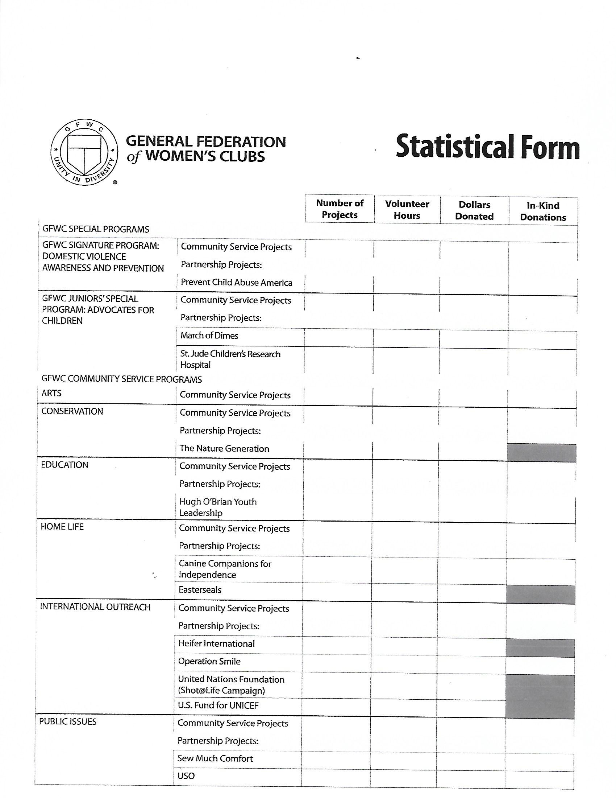

Only ONE Statistical Form is necessary per club. Preferred method is to scan and email this completed Statistical Form to GFWC-WI Second Vice President at AbbyLorenz@wi.rr.com.

**2016**

**Club Name** ______________________________________________________

**District** _________________________________________________________

**Club Name** ______________________________________________________

**District** _________________________________________________________

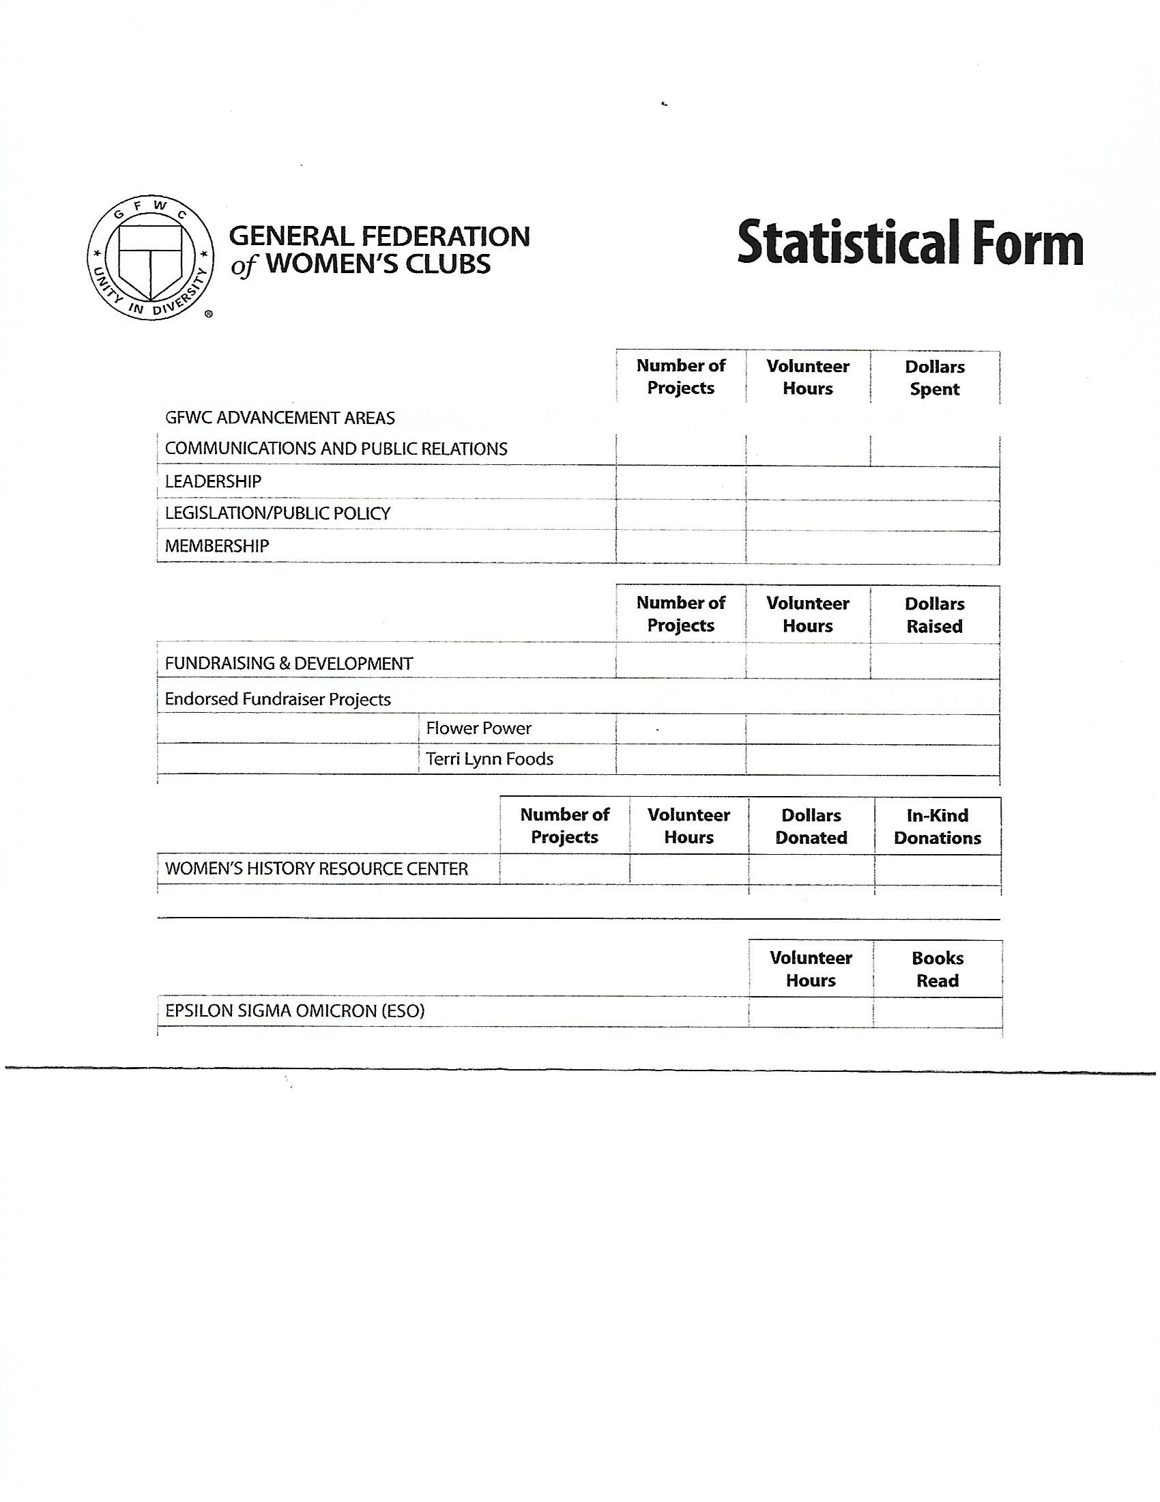

Page 2