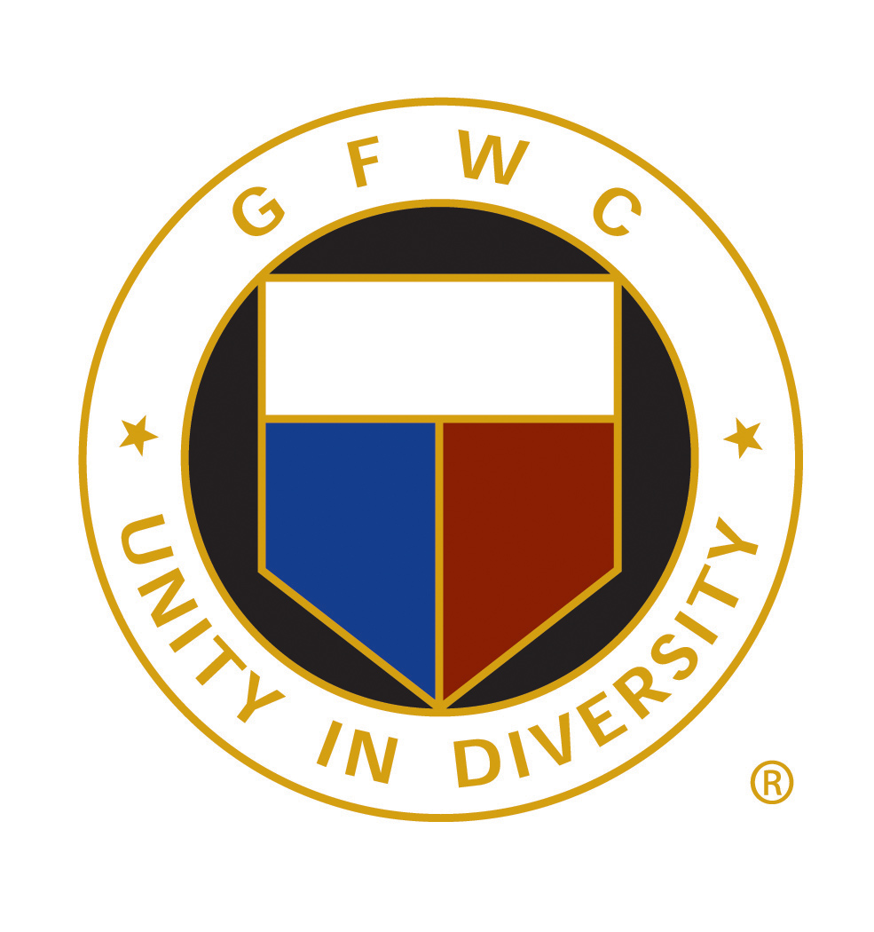

This program offers clubs a financial incentive to implement one impactful project that either meets a specific need in their community or addresses a GFWC Community Connection Initiative:
  - Signature Program: Raise Awareness to Hope and Help
  - Juniors’ Special Program: Refresh and Revive
  - Arts and Culture: Community Historical Gems
  - Civic Engagement and Outreach: A Little Thanks Goes a Long Way
  - Education and Libraries: Bring the Sparkle to Public Libraries
  - Environment: Sparkling Seeds, Brilliant Butterflies, Glamorous Garden Gloves
  - Health and Wellness: Physical Fitness Opportunities for All Ages
Award Rules
Award Period
January 1, 2022 to December 31, 2023
Contest Description
The award entry form project description (2 pages) includes
- Brief description of the project and the problem/need/issue to be solved
- Project scope: plan of action; costs, funding; community collaboration (if any); obstacles (if any)you overcame
- Results achieved: long-term community effects, club effects
- Public relations & media (photos, newspaper articles, social media, etc.)
Entry Process
Visit the GFWC Club Manual, “Community Impact Programs Awards,” for the entry form and more details.

Calendar
January/February 2024
State CIP Award chair obtains 3 nonGFWC members.
March 1, 2024
Club entries must be sent via mail (postmarked no later than March1)
or email to Carol Wolfenden, state chair.
March 5-15, 2024
Club entries judged at state level.
March 20, 2024
GFWC-WI’s winning award entry due to GFWC.
GFWC will issue checks after winner is announced at state convention.
April 2024
National judging at GFWC Headquarters in Washington, D.C.
Spring 2024
State CIP Award presented at May state convention.
June 2024
GFWC CIP Award presented at GFWC Convention in Chicago, IL.

