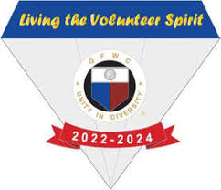
Entry Form
THEODORA YOUMANS CITIZENSHIP AWARD
Deadline April 1st

NAME OF CANDIDATE

ADDRESS

PHONE EMAIL
NAME OF SPONSORING CLUB
CLUB PRESIDENT ADDRESS
PHONE EMAIL

Please send three (3) copies of the entry and letters of endorsement to:

Diane Zickert
230 Achievement Dr. Apt A6
Brillion WI 54110

Note that the candidate need not be a member of a woman’s club. When writing the entry, background information is extremely helpful to the judges, but the stress should be on the work done in the year prior to the nomination. If the candidate is an employed person, her work which is above and beyond the requirements of her employment must be emphasized!

Please include three (3) letters of endorsement from community people who know the candidate’s work.

If your candidate is chosen as the recipient and if it is possible, please do not let her know she is to be recognized – the surprise element adds so much to the presentation! Please be sure to make a dinner reservation for her.

Forms must be postmarked by April 1st !

